**Module Pool Programming with Table Control**

***Program theme:*** *In this demo program you will get how to work Module Pool with the Table Controls to display the data with the table format.*

**Step # 1:** Go to SE38 / SE80 Transaction code and create a Module Pool Program (Program Type – M).

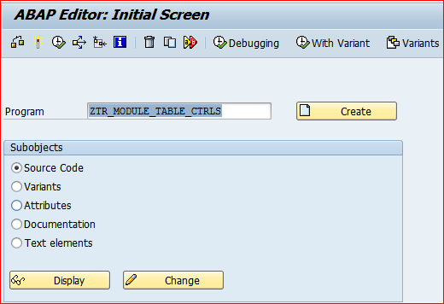

**Step # 2:** Provide the title and select program type Module Pool - M and click on save button.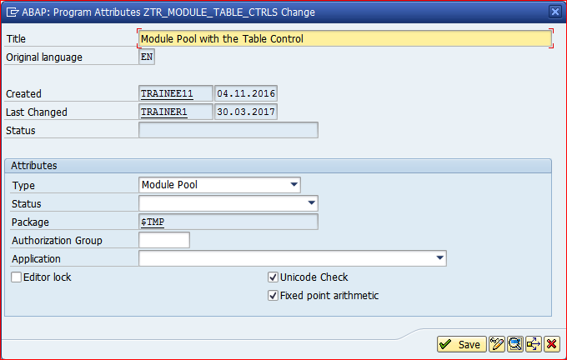

**Step # 3:** Save it in the package.

**Step # 4:** Write module pool program code logic based on the events.

*\*&---------------------------------------------------------------------\**  
*\*& Modulpool  ZTR_MODULE_TABLES_CTRLS*  
*\*&*  
*\*&---------------------------------------------------------------------\**  
  
PROGRAM ZTR_MODULE_TABLE_CTRLS.  
  
TABLES : MARA.  
  
CONTROLS TC1 TYPE TABLEVIEW USING SCREEN 200.  
  
DATA LINKS TYPE TABLE OF TLINE.  
  
TYPES : BEGIN OF TY_TAB,  *" LOCAL STRS*  
          MATNR TYPE MATNR , *" Material Number*  
          MBRSH TYPE MBRSH, *" Industry sector*  
          MTART TYPE MTART, *" Material Group*  
          MEINS TYPE MEINS, *" Base Unit of Measure*  
          BRGEW TYPE BRGEW, *" Gross weight*  
          NTGEW TYPE NTGEW, *" NET weight*  
        END OF TY_TAB.  
  
DATA :IT_TAB TYPE STANDARD TABLE OF TY_TAB, *"  ITAB*  
      WA_TAB TYPE TY_TAB.  *" WORKAREA*  
  
DATA: LV_MATNR1 TYPE MARA-MATNR,  
      LV_MATNR2 TYPE MARA-MATNR.  
*\*&---------------------------------------------------------------------\**  
*\*&      Module  STATUS_0100  OUTPUT*  
*\*&---------------------------------------------------------------------\**  
*\*       text*  
*\*----------------------------------------------------------------------\**  
MODULE STATUS_0100 OUTPUT.  
  SET PF-STATUS SPACE.  
*\*  SET TITLEBAR 'xxx'.*  
ENDMODULE.  
*\*&---------------------------------------------------------------------\**  
*\*&      Module  USER_COMMAND_0100  INPUT*  
*\*&---------------------------------------------------------------------\**  
*\*       text*  
*\*----------------------------------------------------------------------\**  
MODULE USER_COMMAND_0100 INPUT.  
  CASE SY-UCOMM.  
    WHEN 'NEXT'.  
      SELECT MATNR  
             MBRSH  
             MTART  
             MEINS  
             BRGEW  
             NTGEW  
        FROM MARA  
        INTO TABLE IT_TAB  
        WHERE MATNR  
        BETWEEN LV_MATNR1 AND LV_MATNR2.  
      LEAVE TO SCREEN 200.  
  ENDCASE.  
ENDMODULE.  
*\*&---------------------------------------------------------------------\**  
*\*&      Module  USER_COMMAND_0200  INPUT*  
*\*&---------------------------------------------------------------------\**  
*\*       text*  
*\*----------------------------------------------------------------------\**  
MODULE USER_COMMAND_0200 INPUT.  
  CASE SY-UCOMM.  
    WHEN 'BACK'.  
      LEAVE TO SCREEN 100.  
  ENDCASE.  
ENDMODULE.  
*\*&---------------------------------------------------------------------\**  
*\*&      Module  STATUS_0200  OUTPUT*  
*\*&---------------------------------------------------------------------\**  
*\*       text*  
*\*----------------------------------------------------------------------\**  
MODULE STATUS_0200 OUTPUT.  
*\*  SET PF-STATUS 'xxxxxxxx'.*  
*\*  SET TITLEBAR 'xxx'.*  
ENDMODULE.  
*\*&---------------------------------------------------------------------\**  
*\*&      Module  MAT_MAST  INPUT*  
*\*&---------------------------------------------------------------------\**  
*\*       text*  
*\*----------------------------------------------------------------------\**  
MODULE MAT_MAST INPUT.  
  
DATA: BEGIN OF IT_TAB2 OCCURS 0,  
         MATNR TYPE MATNR,  
  END OF IT_TAB2.  
  
SELECT MATNR FROM MARA INTO TABLE IT_TAB2.  
  
CALL FUNCTION 'F4IF_INT_TABLE_VALUE_REQUEST'  
  EXPORTING  
   RETFIELD               = 'MATNR'  
   DYNPPROG               = SY-REPID  
   DYNPNR                 = SY-DYNNR  
   DYNPROFIELD            = 'MATNR'  
   VALUE_ORG              = 'S'  
  TABLES  
    VALUE_TAB              = IT_TAB2  
          .  
IF SY-SUBRC <> 0.  
*\* Implement suitable error handling here*  
ENDIF.  
ENDMODULE.  
*\*&---------------------------------------------------------------------\**  
*\*&      Module  MAT_HELP  INPUT*  
*\*&---------------------------------------------------------------------\**  
*\*       text*  
*\*----------------------------------------------------------------------\**  
MODULE MAT_HELP INPUT.  
  
CALL FUNCTION 'HELP_OBJECT_SHOW'  
  EXPORTING  
    DOKCLASS                            = 'TX'  
    DOKLANGU                            = SY-LANGU  
    DOKNAME                             = 'DEMO_FOR_F1_HELP'  
    DOKTITLE                            = 'MAT MASTER HELP'  
    CALLED_BY_PROGRAM                   = SY-REPID  
*\*   CALLED_BY_DYNP                      = '100'*  
    CALLED_FOR_TAB                      = 'MARA'  
    CALLED_FOR_FIELD                    = 'LV_MATNR1'  
*\*   CALLED_FOR_TAB_FLD_BTCH_INPUT       = ' '*  
*\*   MSG_VAR_1                           = ' '*  
*\*   MSG_VAR_2                           = ' '*  
*\*   MSG_VAR_3                           = ' '*  
*\*   MSG_VAR_4                           = ' '*  
*\*   CALLED_BY_CUAPROG                   = ' '*  
*\*   CALLED_BY_CUASTAT                   =*  
*\*   SHORT_TEXT                          = ' '*  
*\*   CLASSIC_SAPSCRIPT                   = ' '*  
  TABLES  
    LINKS                               = LINKS  
*\* EXCEPTIONS*  
*\*   OBJECT_NOT_FOUND                    = 1*  
*\*   SAPSCRIPT_ERROR                     = 2*  
*\*   OTHERS                              = 3*  
          .  
IF SY-SUBRC <> 0.  
*\* Implement suitable error handling here*  
ENDIF.  
  
  
ENDMODULE.  
*\*&---------------------------------------------------------------------\**  
*\*&      Module  CANCEL  INPUT*  
*\*&---------------------------------------------------------------------\**  
*\*       text*  
*\*----------------------------------------------------------------------\**  
MODULE EXIT INPUT.  
  
LEAVE PROGRAM .  
  
ENDMODULE.

**Step # 5:** Go to SE51/ SE80 Transaction code and provide the module pool program name and Screen Number.

Note: Module Pool program name and screen program name should be same and for Screen number you can enter any number other than 1000 (screen number 1000 is reserved for the selection screen - reporting).

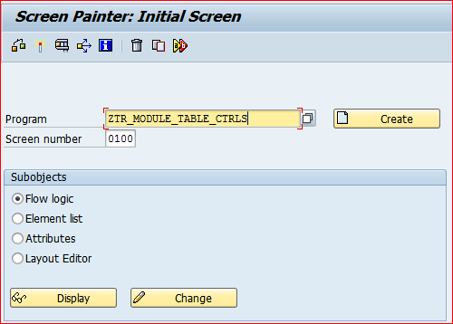

**Step # 6:** Provide the short description and select the screen type radio button Normal.

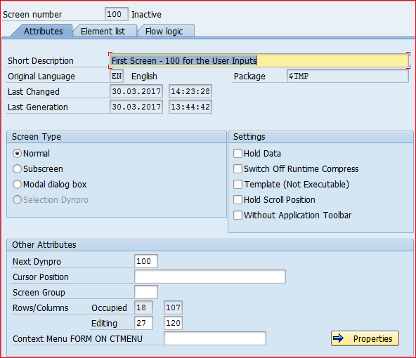

**Step # 7:** Click on Layout button to design the First Screen 100.

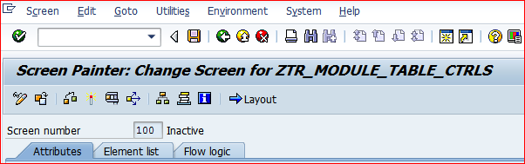

**Step # 8:** Click on Dictionary/ Program fields in the layout screen.

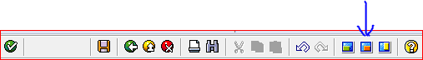

**Step # 9:** Click on the Get from Program option to select the input fields.

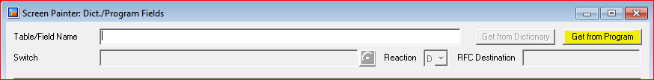

**Step # 10:** Select the fields LV_MATNR1 and LV_MATNR2 drag and drop on to the screen layout for the input.



**Step # 11:** Design the screen with two input fields (LV_MATNR1 and LV_MATNR2) and two push buttons NEXT (Function Type Normal) and EXIT (Function Type E) as showed in the below screen.

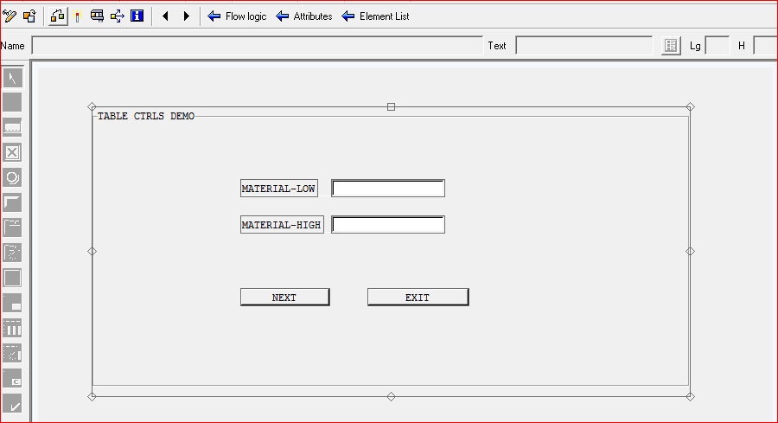

**Step # 12:** Provide the Conv. Exit ALPHA for two input fields (LV_MATNR1 and LV_MATNR2).

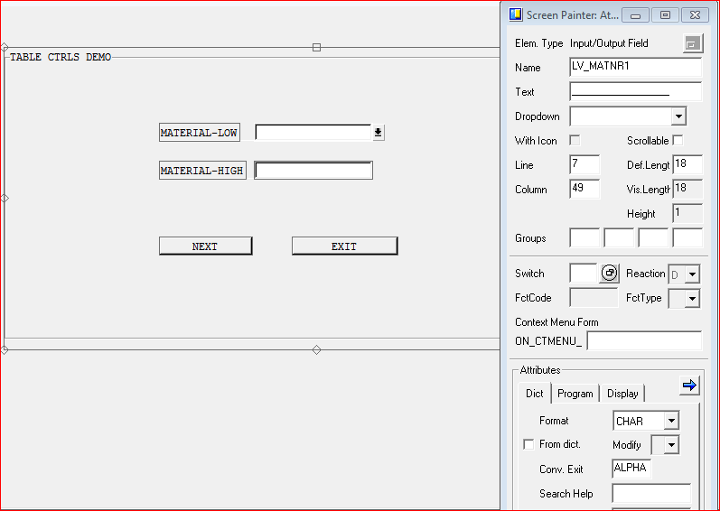

**Step # 13:** Click on the Flow Logic and write the code as showed in the below screen.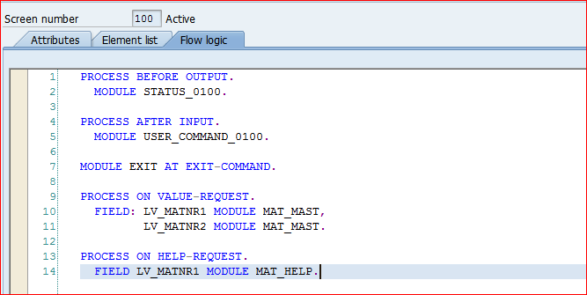

**Step # 14:**  Back to initial screen and design the screen 200 for the table control output.

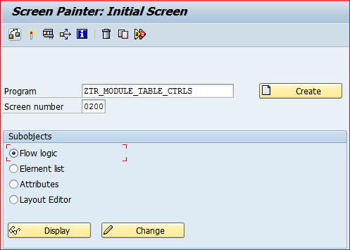

**Step # 15:** Provide the short description and select the screen type radio button Normal.

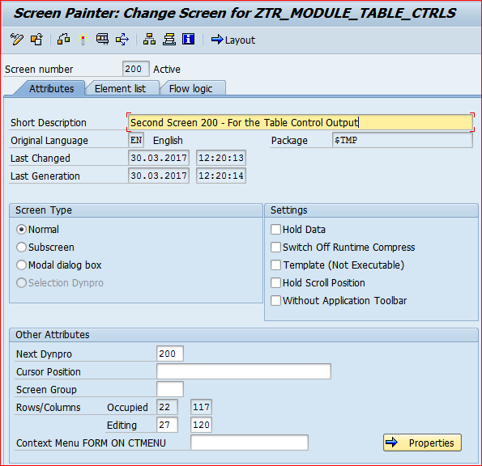

**Step # 16:** Click on Layout button to design the Second Screen 200.

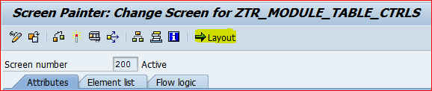

**Step # 17:** In the layout properties select the table control option and drag and drop it based on the requirement and click on the table control.

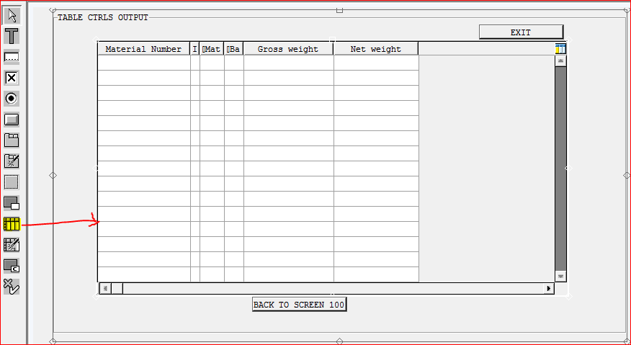

**Step # 18:**  Provide the table control name.

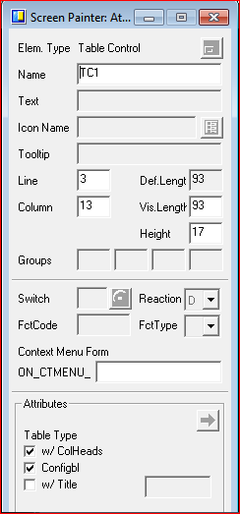

**Step # 19:** Click on dictionary/ program fields in the layout screen.



**Step # 20:** Click on the Get from Program option to select the table fields.



**Step # 21:** Select the WA_TAB fields from the list and click on continue.

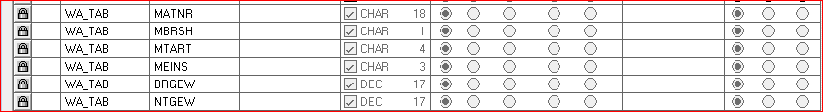

**Step # 22:** Drag and drop on to the table control screen. Provide the table column headings and design the two pushbuttons as specified in the below screen.

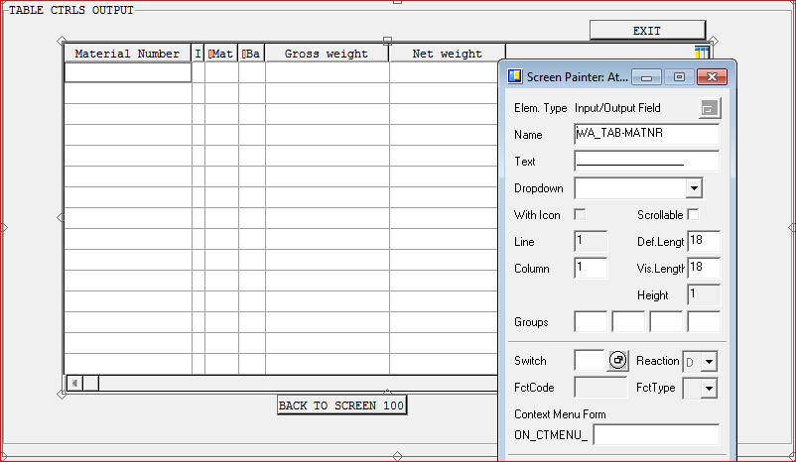

**Step # 23:** Click on the Flow Logic and write the code as showed in the below screen.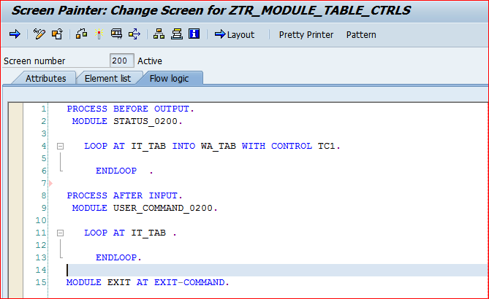

**Step # 24:** Activate the Screen 100 and 200.

**Step # 25:** Activate the SE38 / SE80 Module Pool Program.

**Step # 26:** Go to Transaction Code SE93 / SE80 to create the user defined module pool t-code for the designed application.

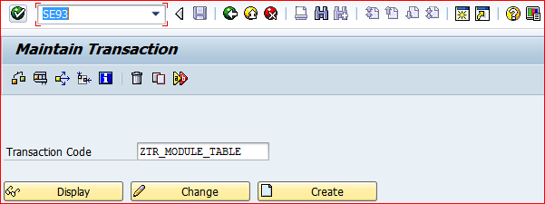

**Step # 27:** Provide the transaction text, program name and initial screen number.

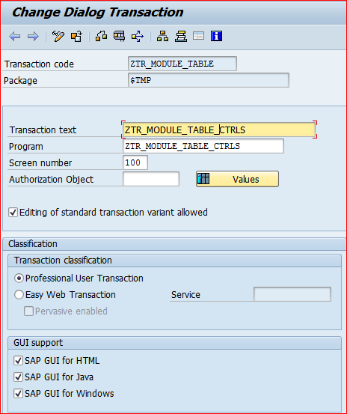

**Step # 28:** Provide the user defined T-Code in the initial screen command and run the Module Pool Application.

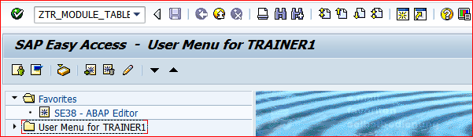

**Step # 29:** 1) lick on the F4 (POV Option) Icon and select the Material Number Low and Material Number – High range and click on NEXT Button.

2) Click on EXIT Button to leave the program.

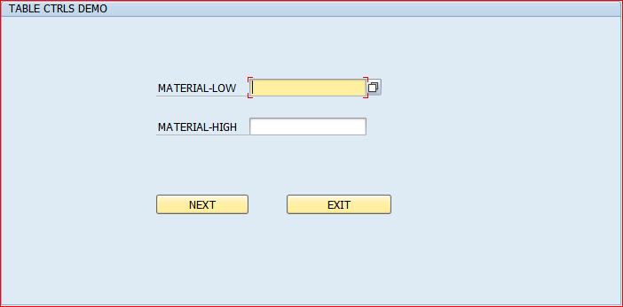

**Step # 30:**  Displayed Table Control Output.

1) Click on BACK TO SCREEN 100 Button to change the input selection.

2) Click on EXIT Button to leave the program.

